Generative Grammar

🔹 What is Generative Grammar
# Source: Chatgpt (GPT-4-turbo) at [8/3/2025]
Generative grammar is a formal system of rules that attempts to define the implicit knowledge native speakers have about how sentences are formed.
It was introduced by Noam Chomsky in the 1950s and is foundational in modern linguistics.
It is called “generative” because it can generate (produce or account for) all grammatical sentences of a language—and only those.

✅ Key Features of Generative Grammar:
# Source: Chatgpt (GPT-4-turbo) at [8/3/2025]
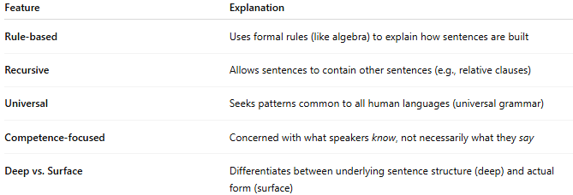
Feature | Explanation
Rule-based | Uses formal rules (like algebra) to explain how sentences are built
Recursive | Allows sentences to contain other sentences (e.g., relative clauses)
Universal | Seeks patterns common to all human languages (universal grammar)
Competence-focused | Concerned with what speakers know, not necessarily what they say
Deep vs. Surface | Differentiates between underlying sentence structure (deep) and actual form (surface)

✅ Example of Generative Grammar in Action:
# Source: Chatgpt (GPT-4-turbo) at [8/3/2025]
Suppose we have the sentence:
“The dog chased the cat.”
Generative grammar would analyze it using phrase structure rules like:
- S → NP + VP (a sentence is a noun phrase + verb phrase)
- NP → Det + N (a noun phrase is a determiner + noun)
- VP → V + NP (a verb phrase is a verb + noun phrase)
This generates the syntactic structure of the sentence.

✅ Deep Structure vs. Surface Structure:
# Source: Chatgpt (GPT-4-turbo) at [8/3/2025]
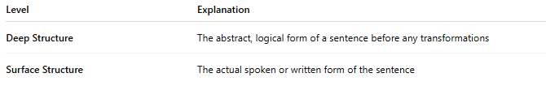
Level | Explanation
Deep Structure | The abstract, logical form of a sentence before any transformations
Surface Structure | The actual spoken or written form of the sentence
Example:
- Deep: "John is eating the cake."
- Surface: "The cake is being eaten by John."
Both share the same underlying structure but differ on the surface.

✅ Transformational Rules:
# Source: Chatgpt (GPT-4-turbo) at [8/3/2025]
These rules explain how one type of sentence turns into another, such as:
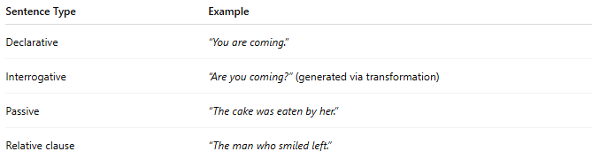
Sentence Type | Example
Declarative | “You are coming.”
Interrogative | “Are you coming?” (generated via transformation)
Passive | “The cake was eaten by her.”
Relative clause | “The man who smiled left.”

✅ Why Generative Grammar Matters:
# Source: Chatgpt (GPT-4-turbo) at [8/3/2025]

- Explains how language is mentally organized
- Essential to syntax, computational linguistics, AI, and language acquisition theory
- Provides a formal model of grammar rules in any language

✅ Comparison with Other Grammar Types:
# Source: Chatgpt (GPT-4-turbo) at [8/3/2025]
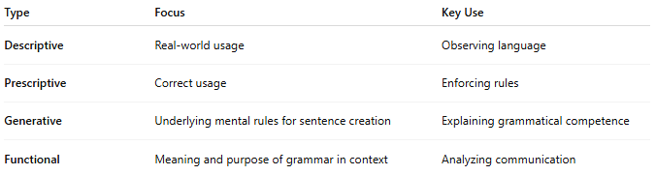
Type | Focus | Key Use
Descriptive | Real-world usage | Observing language
Prescriptive | Correct usage | Enforcing rules
Generative | Underlying mental rules for sentence creation | Explaining grammatical competence
Functional | Meaning and purpose of grammar in context | Analyzing communication

📝 Summary:
# Source: Chatgpt (GPT-4-turbo) at [8/3/2025]
- Generative grammar = a system of rules that models how native speakers generate grammatical sentences.
- Introduced by Noam Chomsky.
- Focuses on deep structure, transformations, and universal rules.
- Foundation for modern syntax theory and language acquisition research.

